Java Arrays
To declare an array, define the variable type with square brackets:
String[] cars; //recommended
String cars[];
String[] cars= new String[5]; //String array declaration with size

We have now declared a variable that holds an array of strings. To insert values to it, you can place the values in a comma-separated list, inside curly braces:
String[] cars = {"Volvo", "BMW", "Ford", "Mazda"}; This is hard-coded

Default Values in Arrays

Data Type | Default Value
int | 0
float | 0.0
boolean | false
char | '\u0000'
String / Object | null

We can edit array elements.
String[] cars = {"Volvo", "BMW", "Ford", "Mazda"};
int[] myNum = {10, 20, 30, 40};

how to access
String[] cars = {"Volvo", "BMW", "Ford", "Mazda"};
System.out.println(cars[0]);
// Outputs Volvo

We can assign other value to array elements.
String[] cars = {"Volvo", "BMW", "Ford", "Mazda"};
cars[0] = "Opel";
System.out.println(cars[0]);
// Now outputs Opel instead of Volvo

Array Methods
String[] cars = {"Volvo", "BMW", "Ford", "Mazda"};
System.out.println(cars.length);
// Outputs 4

ArrayIndexOutOfBoundsException
Occurs when accessing invalid index
Index starts from 0
Max index = length - 1
Array | Collection
array.length | list.size()
Property | Method
Fixed size | Dynamic

The Arrays class in java.util package is a part of the Java Collection Framework. It consists of only static methods and the methods of Object class
. The methods of this class can be used by the class name itself.
The class hierarchy is as follows:
java.lang.Object
? java.util.Arrays

Array Sort
int[] array = {3, 2, 1};
Arrays.sort(array);
for (int i : array) {
System.out.print(i + " ");
}

Arrays equals

int[] array1 = {1, 2, 3};
int[] array2 = {1, 2, 3};
boolean isEqual = Arrays.equals(array1, array2);
System.out.println(isEqual);

Arrays binarySearch
but requires the array to be sorted first.
int[] array = {1, 2, 3, 4, 5};
int index = Arrays.binarySearch(array, 3);
System.out.println(index);

Arrays.toString(array)
Arrays.deepToString(2Darray)
Arrays.fill(array, value)
Arrays.copyOf(array, newLength)
Arrays.copyOfRange(array, start, end)

Memory Allocation of Arrays
Arrays stored in heap
Reference stored in stack
Continuous memory for primitive arrays

Aspect | Primitive Array | Object Array
Array object | Heap | Heap
Reference | Stack | Stack
Elements | Actual values | References
Continuous memory | ✅ Yes | ❌ Only references
Objects continuous | N/A | ❌ No

Exploring Alternative Approaches to Array Manipulation

Using ArrayLists for Dynamic Arrays
While Java arrays are powerful, they have a limitation: their size is fixed at the time of creation. To overcome this, we can use ArrayList, a resizable array implementation in the Java Collections Framework.

Arrays vs ArrayList
Arrays | ArrayList
Fixed size | Dynamic size
Faster | Slightly slower
Can store primitives | Stores objects only
No methods | Rich API

Java Multidimensional Arrays

How to initialize a 2d array in Java?
int[][] a = {
{1, 2, 3},
{4, 5, 6, 9},
{7},
};
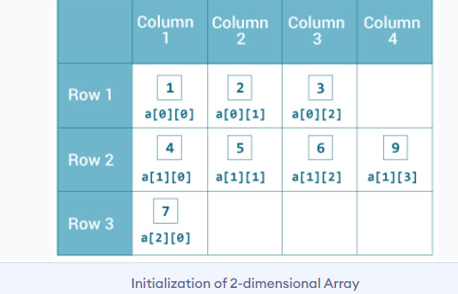

Example: Print all elements of 2d array Using Loop
class MultidimensionalArray {
public static void main(String[] args) {
int[][] a = {
{1, -2, 3},
{-4, -5, 6, 9},
{7},
};

for (int i = 0; i < a.length; ++i) {
for(int j = 0; j < a[i].length; ++j) {
System.out.print(a[i][j]);
} } } }
Output:
1 -2 3 -4 -5 6 9 7

Mostly you will see questions related to Multidimentional Arrays.

Jagged Array
2D array with different column sizes
int[][] a = {
{1,2,3},
{4,5},
{6}
};
In Java, even a 2D array is internally a jagged array, but with equal-sized rows.

Array of Objects
class Student {
int id;
}
Student[] students = new Student[3];

What Actually Happens in Memory?
No Student objects are created yet
What gets created:
An array of size 3
Each element stores null reference

Creating Objects:
students[0] = new Student();
students[0].id = 1;

What does an array of objects store — objects or references?
An array of objects stores references to objects, not the actual objects.

Expanded Answer
Array itself is an object
Each index holds a reference
Actual objects are stored separately in heap
Default value is null
This is why NullPointerException is common with object arrays.

Common Interview Trap
Student[] students = new Student[3];
students[0].id = 10; // ❌ NullPointerException
Correct way
students[0] = new Student();
students[0].id = 10;

Lets Recall
- Declare define and intilize an array and use all methods.
- Arrays class and when to use and its methods
- 2D-array print all elements and Practice more 2D array questions.
- Jagged arrays vs 2d arrays
- Array of objects.

